Approaches for Quantitative Analysis of Microscopic Collagen Fiber Images for Breast Cancer Prognosis

Target Journal: Journal of Biomedical Optics

Contents

1 Introduction 2

2 Methods 5

2.1 FIRE Algorithm 5

2.2 Preprocessing Algorithms 6

2.2.1 Gaussian 6

2.2.2 SPIRAL- TV 6

2.2.3 tubeness filter 7

2.2.4 Curvelet filter 7

2.3 Test case selection and segmentation evaluation 8

2.4 Simulated test cases 9

3 Results 10

4 Discussion 13

5 Conclusion 14

# Introduction

The extracellular collagen matrix has been found to be an important player in the progression of many diseases. The details of collagen's role in these diseases are the subject of intense biomedical research. Much of this research has been enabled by the capability of laser scanning microscopy techniques, in particular second harmonic generation (SHG) imaging, to capture high-resolution, high-contrast images of individual collagen fibers in tissue and in-vitro tissue models. For example, Conklin et. al. (2011) showed that patterns in SHG images of collagen can be used to predict breast cancer patient outcome. Raub et. al. (2007) showed that SHG image characteristics could be used to predict bulk mechanical properties of collagen hydrogels, a common in-vitro tissue model. Nadiarnykh et. al. (2010) and Watson et. al. (2012) found that SHG image characteristics in ovarian tissue provide quantitative discrimination between tumor and benign tissue. Image analysis is a bottleneck in the attempt to scale these types of research projects up to larger sample populations, a key requirement for further biological hypothesis validation. Manual analysis has been attempted, however inter-observer and intra-observer variance can be significant and time requirements prohibitive. Computer assisted image feature extraction is poised to help solve this challenge. To be most useful for a wide variety of biomedical applications, computational tools for collagen image analysis should be capable of extracting high-level information about individual collagen fibers, including fiber number, length, angle, curvature, and position (why is this information needed/important?). This type of detailed high-level fiber information is necessary for understanding how cells interact with individual collagen fibers. In addition, tools should be able to extract this fiber based information from a heterogeneous collection of image morphologies and a wide range of image qualities. Although a number of researchers have developed tools for computer assisted collagen image analysis, to our knowledge no techniques exist for extracting fiber level information from the wide range of morphologies and image quality levels observed in practice.

Many different patterns can be observed in collagen structure, within a single tissue type. As shown in Figure 1, collagen fibers can be wavy or straight (Fig. 1A and B), dense or well defined (Fig. 1C and D), bundled or individually present (Fig. 1E and F). In addition, depending on imaging parameters such as depth within the tissue, images can have low signal to noise (SNR) and potentially low dynamic range (Fig. 1G, H, I, and J). The quantitative analysis of collagen images produced by laser scanning microscopy is challenged by this heterogeneous collection of patterns and image qualities.

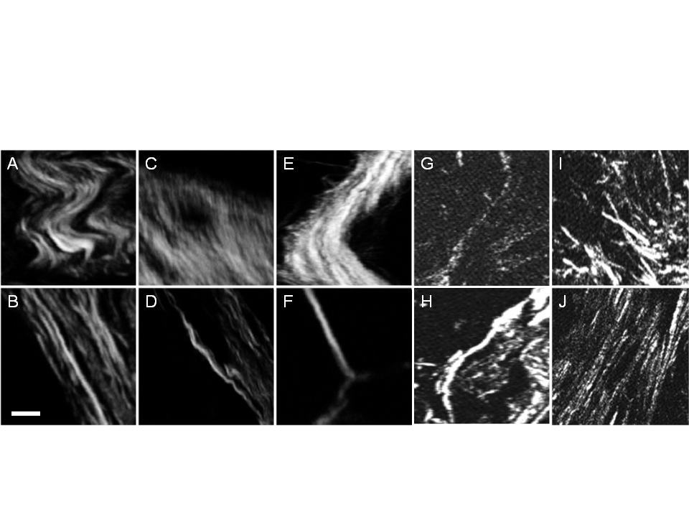

Figure 1. Representative collagen patterns observed in human breast cancer tissue sections. Wavy (A) and straight (B). Dense (C) and well defined (D). Thick bundles (E) and thin strands (F). Discontinuous (G) and continuous (H). Crossing (I) and parallel (J). Scale bar = 10 microns.

Although computational tools have been developed for quantifying the architecture of collagen networks in images (refs), none have the ability to extract fiber based features from such a diversity of patterns. Transform or texture based methods (such as those published by Falzon (FT), Bayan (FT, Hough), Pehlke (Curvelet Trans), Frisch (FT, Fractal), Altendorf (Directional gradients) , Wenyan (Gray level co-occurence) etc.) can handle a wide diversity of images, however lack the ability to extract significant high level fiber based information. For example, transform based methods provide general information about fiber size and direction at each point in an image, but cannot determine the actual fiber number, length or curvature. The result of these methods is not sensitive to, for example, the difference between randomly oriented straight fibers and long curvy fibers. They would have difficulty sensing changes to fiber length, curvature or number and would be challenged to identify cellular interactions with individual fibers. On the other hand, fiber tracking and extraction methods (such as those published by Wu and Stein) have been developed to extract high level fiber information from images of collagen matrices. These fiber extraction methods enable the automated measurement of important high level parameters such as fiber length and curvature, but often fail to properly segment fibers in the dense or low SNR situations commonly encountered while SHG imaging in tissue. An example of a noisy SHG image is shown in Figure 2A. Without preprocessing, the FIber Extraction (FIRE) algorithm, developed by Stein (Stein 2008), produces many false positive fibers and an overly complex fiber network. For the dense collagen pattern shown in Figure 2B, FIRE extracts erroneous star patterns and fails to identify the most prominent fibers extracted by a human observer. Our hypothesis is that with proper preprocessing steps, significantly improved collagen fiber extraction is possible in SHG images of tissue.

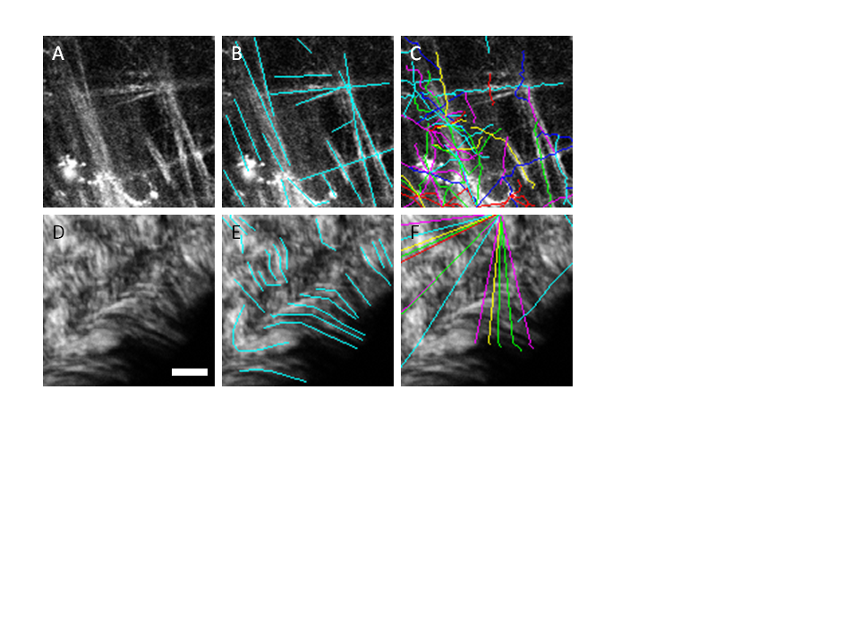

Figure 2. Fibers extracted by the FIRE algorithm without preprocessing. A and D are the original images, B and E are show manual segmentations of the fibers, D and F show the automatic fiber segmentations that are extracted by the FIRE algorithm. Scale bar =25 microns.

In this paper, we compare four image preprocessing techniques with the ultimate goal of improving the accuracy of high level fiber extraction with an algorithm such as FIRE. The preprocessing techniques we compare are the simple Gaussian filter, the SPIRAL-TVX filter (Harmony 2012 ref), the tubeness filter (Sato 1998 ref), and a curvelet transform based denoising filter (Stark 2002 ref). Other than the Gaussian filter, these filters were chosen based on their published ability to highlight edge information in images while simultaneously suppressing spatially uniform structures and noise. We have chosen to use the FIRE algorithm based on evidence of its ability to extract fibers from in-vitro collagen gel networks and its availability (web ref), however, other fiber extraction tools may be substituted for the FIRE algorithm. We have focused our analysis on 2D images, since standard SHG microscopy has difficulty detecting axially aligned fibers (ref Yew 2006, 2007), however our methods may be naturally extended to 3D without significant alteration. We demonstrate here that the application of curvelet transform denoising as a preprocessing step for FIRE fiber extraction, a process we call CT-FIRE, performs more accurate fiber segmentations than any of the other techniques we investigated, in a variety of collagen images of human breast and mouse mammary tissue. We then show that CT-FIRE accurately extracts fiber information from a collection of synthetic test images where the true segmentation is well-defined.

This paper is organized as follows. Section 2 gives a brief description of the FIRE algorithm, describes preprocessing algorithm implementations, how each image was manually segmented, how the image segmentation was evaluated, and finally how the synthetic test images were created and evaluated. In section 3, we compare the ability of the four preprocessing algorithms to extract fiber information by comparing their agreement to a panel of human observers. We also highlight the ability of CT-FIRE to extract accurate collagen information from synthetic test cases. In the fourth section we discuss our results and in the fifth section conclude by describing the future directions of our research.

# Methods

Four algorithms were evaluated as preprocessing steps to the FIRE fiber extraction algorithm. For completeness, we will first briefly review the FIRE process. A more detailed description of the algorithmcan be found in reference (Stein 2008).

## FIRE Algorithm

FIRE is an image reconstruction based method that can extract the geometric structure of three dimensional collagen images. The main steps of this method include applying a threshold to form a binary image, the distance transform on the binary image to yield the minimal distance from the fiber pixel to the background, tracing along the maximal ridges of the smoothed distance function to form fiber branches by identifying nucleation points and extending the fiber from each nucleation point. Short fiber branches are then pruned and fibers are linked based on the fiber length, fiber direction and the distance between adjacent fibers. In the associated software(which can be downloaded from ref), there are about 20 adjustable parameters. However, in practical application, given the default parameters, there are usually only a few parameters that need to be adjusted, such as those impacting the binary image generation, the search for nucleation points and fiber linkage. To our knowledge, the FIRE method has only been tested on confocal reflectance and confocal fluorescence images of in-vitro collagen gels, but has not been applied to extract collagen fibers from SHG images of tissue.

Each preprocessing technique described in this paper was followed by nearly identical implementations of the FIRE algorithm. The only difference is in the first FIRE threshold used for creating the initial binary image. This threshold was hand optimized to produce the highest quality fiber extractions across all test cases.

## Preprocessing Algorithms

The four preprocessing algorithms evaluated here are described briefly below. More detailed background information on the advanced filters can be found in their respective references.

### Gaussian

A simple 2-D Gaussian filter, whose standard deviation was matched to the average width of the collagen fibers in our images of 1.5 microns, was used as a baseline for comparison against the other more advanced filters.

### SPIRAL- TV

The SPIRAL-TV algorithm, by Harmany et. al. (Harmany 2012) was developed to accurately extract features from images where Poisson noise dominates, a common occurrence in SHG imaging of collagen in tissue, and has applications in compressed sensing, nuclear medicine tomographic reconstruction and superresolution reconstruction in astronomy. The algorithm iteratively approximates a solution to the minimization problem given by

$$f^{k+1}=\underset{f∈R^{n}}{arg min}{F^{k}\left(f\right)+τ*pen\left(f\right)}$$

$$subject to f≥0$$

where $f$ is the approximation to the image of interest, $F^{k}\left(f\right)$ is the negative Possion log-likelihood function at iteration *k*, and $pen\left(f\right)= {\left\|f\right\|}_{TV}$ is the total variation seminorm penalty scheme. SPIRAL-TVX was shown to perform well at highlighting strong edges in images and smooth noise in low gradient areas (Harmany ref). The designers of this algorithm have tested it on noisy computed tomography reconstruction data however it has not been applied to preprocessing for fiber extraction from SHG images.

### tubeness filter

The tubeness filter is an ImageJ pluggin implemented by Longair, Preibisch and Schindelin (Schindelin 2012, NatMeth) and is based on the work published by Sato et. al. (1998). The algorithm highlights fiber-like structures in images while attenuating homogeneous or noisy regions and has found application in processing images of neurons and blood vessels (Sato '98, Longair 2011). This filter enhances fiber structures by first applying a 2-D Gaussian filter with $σ_{f}$ matched to the width of the fiber. Next, the Hessian is computed at each point in the image and the eigenvalues, $λ_{1}$ and $λ_{2}$ for the 2-D case, of the Hessian matrix are found. The resulting pixel value is given by the following rule:

$$λ_{g}=\left\{\begin{matrix}\left|λ_{2}\right|, λ_{2}<0 \\ 0, otherwise\end{matrix}\right.$$

To our knowledge, this filter has not be evaluated for its ability to highlight collagen fibers in SHG images of tissue.

### Curvelet filter

We have implemented a denoising filter based on the 2-D curvelet transform. The curvelet transform was developed by Candes and Donoho (Candes 1999 ref) as an alternative to wavelet methods for enhancing edges and lines in noisy images. Our group has recently reported on the successful use of the curvelet transform for finding fiber alignment information in SHG images of collagen (Pehlke ref). Here we report on the use of the curvelet transform as a preprocessing step to high level fiber extraction. Briefly, the curvelet transform represents images as superpositions of elements that are constant along ridge lines and wavelets in the orthogonal direction. The basic form of a curvelet is described in (Stark 2002) and is given by

$$a^{-1/2}ψ\left(\frac{x_{1}cosθ+x_{2}sinθ-b}{a}\right)$$

where $ψ$ is a wavelet, $a>0$ is a scale parameter, $θ$ is an orientation parameter, and $b$ is a position parameter. Curvelet lengths and widths vary with scale and obey the rule $width≈{length}^{2}$. Simple curvelet coefficient thresholding has been shown to be an improvement over advanced denoising techniques based on wavelets such as decimated or undecimated wavelet transforms (Stark 2002). Our denoising implementation reconstructs images using the top 20% of curvelet coefficients from the intermediate scales 4, 5, and 6 with 7 total scales in our test cases. Scale selection may vary with different applications, however we chose to remove the finest scale due to the high noise content present at this scale. The coarser scales (1-3) did not represent the size of the fibers in our images and were therefore discarded.

## Test case selection and segmentation evaluation

Image segmentation quality was evaluated by comparison with expert human segmentation on 25 real test case images. Twenty of the images were of human breast tissue and five of the images were of mouse mammary tissue. Ten of the images were captured using a forward SHG microscope configuration, and 15 of the images were captured with a backward generated SHG configuration. Fifteen of the test cases represented SNR and contrast challenged imaging situations, while 10 of the images represented dense collagen situations. Within the 25 test images, the human observers were asked to manually segment all fibers in each of the test images. The images were annotated using the ImageJ ROI Manager. The ROIs for each of the test cases were saved for each of the 3 observers. These ROIs were then read into Matlab using the Miji toolbox (ref). The fibers extracted by FIRE for each test case, and each algorithm were then compared with the manually extracted fibers for each test case and each observer. A manually segmented fiber was associated with an automated fiber, and vice versa, if the two had similar average angles, similar positions, and similar lengths. The average angle of a fiber was computed by finding the absolute angle of the line connecting the end points of the fiber. Fiber length was computed as the Cartesian distance along the fiber. Distance between fibers was computed as the sum of the distance between the nearest neighboring points between the manual and automatically segmented fibers. The number of true positive fibers ($TP$), false positive ($FP$), and false negative fibers ($FN$) were then found by counting the number of associated manual fibers, unassociated automated fibers, and unassociated manual fibers respectively for each test case. Precision and recall were computed as $Precision=TP/\left(TP+FP\right)$ and $Recall=TP/\left(TP+FN\right)$, and the harmonic sum of the two was computed as follows

$$Fmeasure=2*\frac{Precision*Recall}{Precision+Recall}$$ The $Fmeasure$ result for each of the preprocessing algorithms was averaged over all test cases for a given observer, producing ${Fmeasure}_{1}$. Then the ${Fmeasure}_{1}$ result was averaged over all observers and the standard deviation between observers was computed.

## Simulated test cases

Segmentation quality of the CT-FIRE algorithm was further verified by segmenting fibers out of simulated fiber images where fiber number, fiber length, and fiber angle information was perfectly known. Simulated test cases were created using a similar algorithm to the one reported by Stein (2008). Fibers are drawn into the image one at a time. The initial position and direction of each fiber is selected from a uniform random distribution and overall fiber length was drawn from a Poisson distribution. At each step, a new fiber trajectory is computed by drawing from a scaled uniform random variable and adding the result to the previous trajectory. The scale factor defines the curviness of the fibers in the images. In our test cases, we created images containing half of the fibers at similar angles and half of the fibers at random angles, to create a feature for histogram comparison between the true and measured fiber angles.

# Results

The segmentation results for a selection of representative test cases are shown in Figure 3. Each row in the figure is a different test case, while each column represents a different method of fiber segmentation. Column 1 shows the original images with no overlaid segmentations. Columns 2 through 6 show the original image with overlays of the manual, gaussian filter, SPIRAL-TVX filter, tubeness filter, and curvelet filter segmentations respectively, where FIRE was performed following each of the filter preprocessing steps. Although we had 3 observers manually segment each of the test cases, the manual segmentations shown in column 2 represent the segmentations of a single observer. Each tile in figure 3 is a 128 by 128 pixel crop of a larger image. The test cases in rows A and B were taken with a backward SHG microscope, and are images of five micron thick sections of Invasive Ductal Carcinoma. The test case in row C was taken with a backward SHG microscope and is an image of a resected mouse mammary tumor. The test cases in rows D and E were taken with a forward SHG microscope and are images of five micron this sections of Ductal Carcinoma In-Situ. Even though the images in row A and B have a fairly low signal to noise ratio, their results from each of the four algorithms are comparably similar. For example, in the lower left corner of test case A, we can see that all methods at least partially segmented the long curved fiber indicated by the arrow. However, if we look at the area in case C indicated by the arrow, where 3 fibers run in parallel producing a relative plateau in signal level, we see that the Gaussian and SPIRAL-TVX filters lose the ability to find fiber centers and begin to produce false star patterns. The tubeness and curvelet filters do not perform perfectly in this situation, however, they are able to identify at least one of the three fibers in the bundle. This problem is more obvious in test case D, where many densely packed fibers are running in parallel to each other. In this case, Gaussian and SPIRAL-TVX filters create false star patterns while the tubeness and curvelet filters are able to successfully identify many of the fiber centers. In case E, we see that the fiber indicated by the arrow is most accurately extracted after curvelet filtering compared to all other methods. This is one example of many where the fibers extracted after curvelet filtering most closely match the manual segmentation.

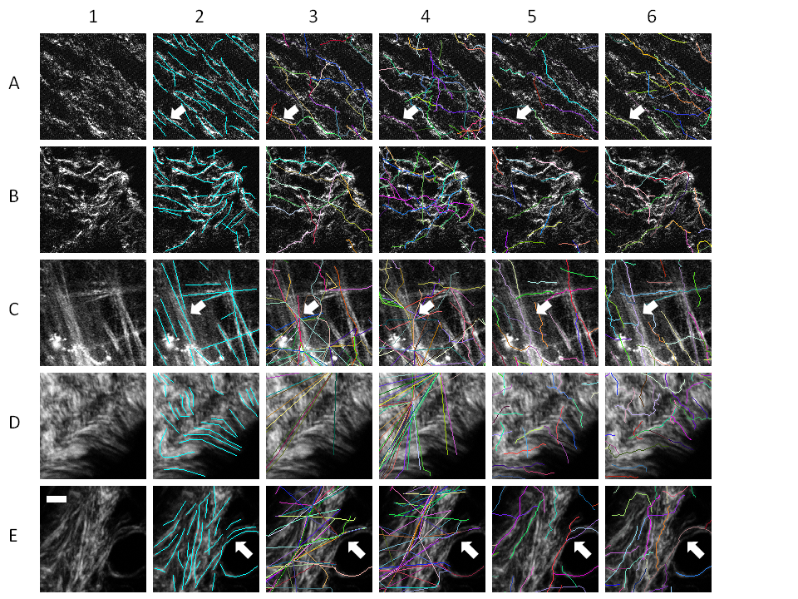

Figure 3. Five different test cases (A-E), showing different processing methods in each column. The original image (column 1) is shown overlayed with a manual segmentation (column 2), Gaussian filter (column 3), SprialTVX (column 4), tubeness (column 5), and curvelet filter (column 6).

The results of each of the fiber extraction preprocessing algorithms were compared against each of the 3 segmentations performed by the independent observers using a collection of custom scripts written in Matlab. If a fiber segmented by the automated process had a similar angle, close proximity, and similar length to a manually segmented fiber, then an association was made between the automated and manual fibers, indicating a true positive. After all fibers were evaluated, all remaining unassociated manual fibers were counted false negatives (misses) and all remaining unassociated automatic fibers were counted false positives (false hits). Precision, recall and their harmonic sum (F-measure) were computed and compiled for all test cases and all observers. Overall average F-measure scores for each of the preprocessing algorithms are shown in Figure 4. The average F-measure score for the curvelet filter was the highest followed by the tubeness, SPIRAL-TVX, and Gaussian filters. The error bars indicate the standard deviation between the F-measure scores from each of the 3 observers and show that the scores between observers were very similar, meaning that the curvelet filter result was the closest match to all 3 observers.

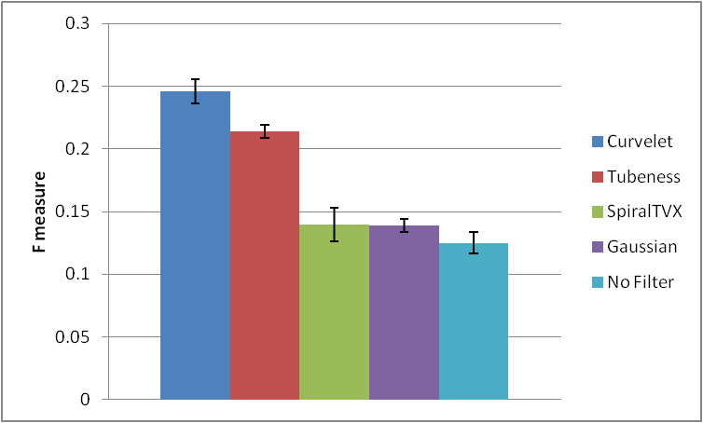

Figure 4. F measure result comparing the automated segmentation techniques to the manual segmentations of three independent raters, for 25 test cases, representing a total of 9290 fiber evaluations. The error bars indicate the standard deviation between average F measure scores of each of the raters.

Based on these data, we decided to focus on our curvelet filter and further evaluate its performance combined with FIRE. To do this, we developed a Matlab script to create noisy synthetic fiber images with known length and angle distributions. Then, we processed these images with the CT-FIRE algorithm to extract length and angle information about the individual fibers. The results of this test are shown in Figure 5. These results show that the CT-FIRE algorithm produces accurate length and angle measures in synthetic images.

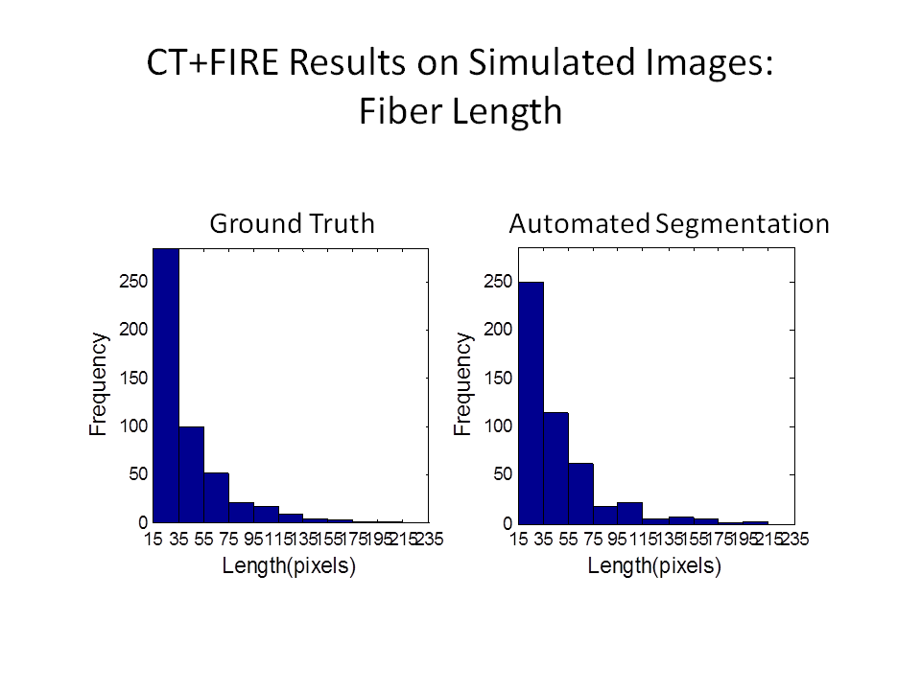

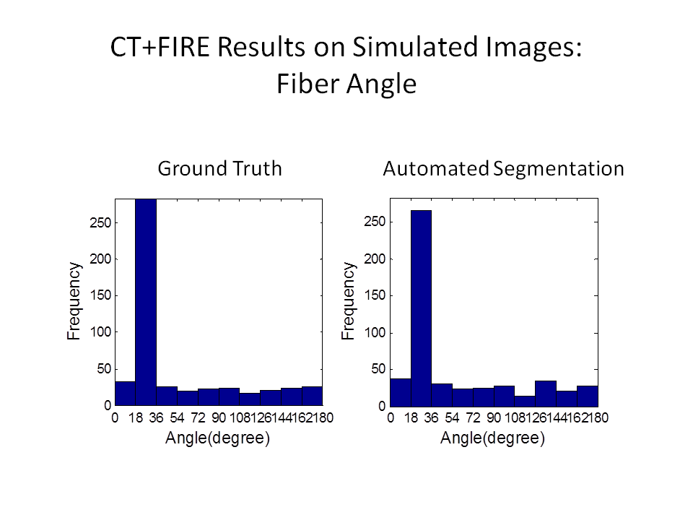

Figure 5. Distribution of lengths (top row) and angles (bottom row) of all fibers in all simulated test cases. Ground truth data is on the left and the results of the automated CT+FIRE algorithm are shown on the right.

# Discussion

(We may consider moving the synthetic fiber analysis to this section to highlight high accuracy of FIRE )

What are pros and cons of each method? Discussion should include computation time, expandability to larger images, ability to handle noise, dense fibers, curvy fibers, fibers of varying thickness and brightness, fibers of varying outline shape (like does the fiber look like a string of pearls vs a straight rod for example).

Quanti vs class

2D vs 3D

FW vs Backwards SHG

Having software that is integrated with analysis solutions

Correlation with other parts of the biology (cells, epithelial regions, tumors)

As we stated in section 1, to our knowledge, FIRE is the only automatic high-level fiber information extraction software available for collagen alignment analysis and was not evaluated for the SHG images. According to our testing, though FIRE works well in some situations without any preprocessing or pre-filtering, it fails in many complicated SHG collagen image analysis such as those shown in section 3. Our work aimed to extend FIRE's applications to complicated SHG images to diagnose various cancers by integrating FIRE with other preprocessing or classification methods. For the purpose of collagen alignment analysis, the results show both curvelet transform and Tubeness filter(TF) are very promising and there are very likely to further improve the fiber extraction accuracy by modifying for example the strategy of extending/merging fiber segments/branches currently adopted in FIRE algorithm. CT and TF could also be integrated with other mature approaches commonly used in for example blood vessel extraction to meet the increasing needs in SHG collagen alignment analysis.(This paragraph may be included in the Conclusion section).As in a recent review [1], curvelet transform has most successful applications when used in combination with other approaches for image processing. By selecting and thresholding the most representative scales, the curvelet transform(CT) based method shows the best performance for both denoising the image and enhancing edge information producing a better fiber extraction among all the proposed preprocessing algorithms discussed in this paper. In addition, the CT based method simplifies the often difficult choice of selecting a threshold to binarize the image early in the FIRE process. Image thresholding can be difficult in low SNR and non-stationary images but can be alleviated through the application of more complicated thresholding techniques (ref) or via the grey level distance threshold (ref). In our case, the inverse curvelet transform makes threshold selection simple by placing the background on the negative side of zero and the forground on the positive side of zero, allowing the threshold to always remain at zero. To take full advantage of the multiscale analysis of curvelet transform based approaches, an optimal scale combination can be obtained according to the features of the images to take into account different fiber width, length and dynamic intensity change. In addition, although the hard thresholding approach used in curvelet transform has robust performance for most cases we have tested, other soft thresholding or scale_adaptive thresholding techniques can be adopted to finely adjust the CT-reconstruction image. The CurveAlign software[ref] previously developed in our group which can be used to show the curvelets center and direction of the fiber edges at a specified scale may also be helpful for choosing the optimal scales and threshold of the curvelet coefficients. These advantages may make FIRE more applicable to deal with a variety of images with complicated features such as low signal to noise ratio, high fiber density, or non-stationary image intensity or contrast

With regard to the other filters, Gaussian filter is a low pass filter and can attenuate the high frequency noise. However, its essential function is to smooth or blur the image which can't meet the needs of fiber edge enhancement. Although the Tubeness plugin in Fiji is capable of enhancing line/curve structures and recovering these structures of different width, it may lose some detailed fiber information such as in ? and its ability of multiscale analysis and fiber orientation extraction for SHG collagen images is yet to be evaluated partly because Tubeness filter is not as a universal and well mathematically grounded multiscale methods as curvelet transform.

It is worth mentioning that, although the preprocessing methods can extend FIRE algorithm's to some degree, they may do little about some intrinsic limitations of FIRE, such as the ability to always properly segment crossing or cross-linked fibers, extremely curvy fibers, or fibers with gaps due to the fibers traveling in and out of the focal plane as we observed in our testing. Advanced or intelligent fiber extension strategy (ref, as Rob mentioned) and fiber segmentation used in other fields may help address this issue.

Given an automated and more accurate high-level collagen fiber extraction, we can anticipate collagen alignment analysis can be practically applied to a huge amount of experimental data and extract more useful information for cancer diagnosis or and other relevant researches ... ( as those mentioned in section 1,emphasis again the importance ).

# Our current work is under both Matlab and Fiji developing environment. To make these approaches more widely accessible to the public, we are planning on developing Fiji plugin of an advanced collagen alignment analysis which may include the function of 2D, 3D collagen fiber/fiber network extraction, cancer diagnosis, ....) Conclusion

Review why accurate, quantitative fiber analysis is important.

Summarize the results.

Conclude with a recommendation for when each method would be appropriate and future directions.